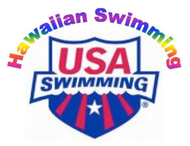
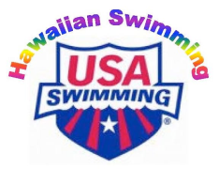
APPLICATION TO OFFICIATE

2016 Hawaiian Swimming Senior LCY Championship
Veterans Memorial Aquatic Center
Friday-Sunday, June 17 - 19, 2016
Applicant must be a current member of USA Swimming and an LSC certified official.
NAME:  Address:  City, State, Zip:  Email address: | LSC CODE: HI  Home Phone:  Work / Cell Phone:
Current Certifications – List Highest Position
LSC/N1: | Exp Date:
National/N2: | Exp Date:
National Championship/N3: | Exp Date:

Accepted applicants must attend all mandatory official’s briefings.
Applications for the assigned positions of Chief Judge, Starter and Deck Referee must be received no later than June 15, 2016. Notification of assigned positions will be sent June 16, 2016. All other applications must be received no later than June 16, 2016; an email response will be sent confirming receipt of your application.
Requested Assignment:
(Stroke & Turn, Chief Judge, Starter or Deck Referee, as needed)
Please check the sessions you will be available to officiate –
I will serve at ALL sessions [ ]

I can only serve at the following sessions –
FRIDAY | JUNE 17, 2016 | PRELIMS [ ] | FINALS [ ]
SATURDAY | JUNE 18, 2016 | PRELIMS [ ] | FINALS [ ]
SUNDAY | JUNE 19, 2016 | PRELIMS [ ] | FINALS [ ]

UNIFORM FOR THIS MEET WILL BE AS FOLLOWS:
All Sessions – White Polo Shirt, Khaki pants (short or long) or skirts (short or long), White Shoes/Socks

Please complete, print to pdf and Return Application by email to:

Marcelle Arakaki, Meet Referee
Cell: (808) 382-4343
Email: marcelle808@gmail.com

Looking forward to a full deck for our swimmers ~ Thank you!

